

ASSET VERIFICATION AND RECORDING TOOL KIT


Plot 31, Bukoto Street
P.O Box 7657, Kampala, Uganda
+256 (0) 39 2000216/0772525235
email: cpa@cpa.ug

www.cpa.com

August to September 2026

VERIFICATION DETAILS

NAME OF THE REGION: | WESTERN REGION
SUB-REGION: | BUNYORO
Name of Local Government | KAKUMIRO DISTRICT LOCAL GOVERNMENT
VERIFIER PARTICULARS
Full name | NAKAGWA HINDU, FATUMAH YASIN, NAKITENDE SHARIFAH
Contact/ email and Telephone | 0702578692 hindunakagwa@gmail.com  0703480094  0703780913
Supervisor/ Sub team leader
Name

Contact
Date of submission

HEALTH CENTRES
INFORMANT INTERVIEW/DISCUSSION GUIDE (INCHARGE OR RESPONSIBLE PERSON)

Name of Health Centre: KIGANDO HEALTH CENTRE III

1a | Does the Facility have a record of all assets provided under UGIFT.  (Obtain a record and verify if it has the costs and numbers supplied | YES
1b | If Not ask how many were supplied and when.

2 | How does this facility Maintain (repair/service/replace) the assets provided under UGIFT  So far, no maintenance, repair, servicing, or replacement of the assets provided under UgIFT has been carried out.

3 | Does the facility take regular record about functionality/ or breakdown of the assets provided? | YES

4 | How has the UGIFT support helped in service delivery in the area, any issues, challenges and any recommendations for better program implementation. | UGIFT Support and Service Delivery  UGIFT support has contributed significantly to the provision of maternity equipment, which has greatly improved the quality and efficiency of maternal healthcare services.  RECOMMENDATIONS  - UgIFT support for repairs: UgIFT should provide support for the repair and maintenance of some of the supplied equipment and the structures constructed under the programme.  - Transport support: UgIFT should consider providing additional transport support, as the health facility currently has only one motorcycle, which is insufficient to meet its operational and service delivery needs.

PROCEED TO VERIFICATION AFTER THIS DISCUSSION

Health centre checklist

NAME OF LG KAKUMIRO DISTRICT LOCAL GOVERNMENT NAME OF HEALTH FACILITY KIGANDO HEALTH CENTRE III

Equipment/ Item | Department | Asset Number | Item  Description | Life in Months | Tag Number ( engrave no.) | Date Of Purchase | Date Placed In Service | Recoverable cost | Cost | Acc Dep Cost | Net Book Value | Ytd Deprn | Equipment status | Remarks
- P. Machine, Digital | MATERNITY, |  | It has a start/stop button white in colour and a cuffis wrapped around the upper arm.  It is operated using batteries |  | KMR/KGD-HC/UGIFT |  | 2023 |  |  |  |  |  | Functioning | Received 1 machine
B.P. Machine (Aneroid wall mounted) | MATERNITY & STORE |  | It doesn’t use batteries. It has a round presssure gauge/ dial with numbers usually from 300mmHg.  Its usually put on the wall. |  | KMR/KGD-HC/UGIFT |  | 2023 |  |  |  |  |  | Functioning | Received 1 machine
Autoclave 20 Liters.,Duo Operated | MATERNITY |  | It’s a large, strong metal chamber with a door, pressure temperature & operating controls |  | KMR/KGD-HC/UGIFT |  | 20203 |  |  |  |  |  | Functioning | Received 1 piece and in use
Bowl, Kick | STORE |  | Stainless stell bowl or basin |  | Not Engraved |  | 13/05/2024 |  |  |  |  |  | Functioning | Received 1 piece and still kept on store
Bowl Stand | STORE |  | Metal frame stand with three legs |  | Not Engraved |  | 2023 |  |  |  |  |  | Functioning | Received 2 pieces and still kept on store
Counting chamber Neubauer- Improved | STORE |  | Small rectangular glass plate. It has a special raised chamber where the sample is placed |  | Not Engraved |  | 2023 |  |  |  |  |  | Functioning | Received 2 pieces and still kept in store.
Cupboard Steel, Lockable | IN CHARGE’S OFFICE & MATERNITY |  | - It is metallic.  - Has 2doors  - Has a lock a nd key  - It has shelves inside for keeping in documents or equipments |  | KMR/KGD-HC/UGIFT |  | 2023 |  |  |  |  |  | Functioning | Received 3 pieces and all in use.
Drip Stand | MATERNITY, OPD & IN PATIENTS |  | - Long vertical metal plole with a stable base having five legs.  - It has hooks at the top for hanging on fluid bags |  | KMR/KGD-HC/UGIFT |  | 2023 |  |  |  |  |  |  | Received 3 pieces and all in use.
ESR Stand | STORE |  | A small white rectangular metal with several holes for holding ESR tubes |  | Not Engraved |  | 2023 |  |  |  |  |  | Functioning | Found 1 piece in store.
Examination Couch | MATERNITY & OPD |  | - Its rectangular in shape with a mattress.  - It has a back rest which is adjustable.  - It has four metallic legs.  - It has a head and lower body section |  | KMR/KGD-HC/UGIFT |  | 2023 |  |  |  |  |  | Functioning | Found 2 pieces and all in use
Examination light,LED | STORE |  | - Black in colour with a flexible adjustable arm and a LED lamp  - It is easily moved  - It has an ON & Off switch.  - It has a fixed stand with a stable base with wheels. |  | Not Engraved |  | 2023 |  |  |  |  |  | Functioning | Found 2 pieces and still kept in store
Glucometer | LAB |  | - White in colour.  - Digital meter screen with test strrips. |  | KMR/KGD-HC/UGIFT |  | 2023 |  |  |  |  |  | Functioning | Found 1 piece in use.
Haemoglobin Meter, Digital | LAB |  | - White Small rectangular electronic device.  - Has digital screen  - Has an opening where a test strip containing blood is inserted. |  | KMR/KGD-HC/UGIFT |  | 2023 |  |  |  |  |  | Functioning | Found 2 pieces and in use.
Height Meter | OPD |  | - It’s a tall vertical measuring rod marked in centimeters  - It has a stable base where a person stands.  - It has a sliding head piece that is lowered to touch the top of the person’s head. |  | KMR/KGD-HC/UGIFT |  | 2023 |  |  |  |  |  | Functioning | Found  2. one in use and the other still kept in store  The one in use is engraved
Instrument Trolley | OPD, LAB, POSTNATAL |  | Its metallic with two trays and four wheels for easy movement |  | KMR/KGD-HC/UGIFT |  | 2023 |  |  |  |  |  | Functioning | Received 4 pieces. in use.
Microscope Binocular | LAB |  | Has two eye pieces at the top  Has a strong base and supporting arm |  | KMR/KGD-HC/UGIFT |  | 2023 |  |  |  |  |  | Functioning | Received 3 pieces one in use
Otoscope | STORE |  | - Handheld instrument used to look inside the ear.  - The handle contains batteries  - Its black in colour. |  | NOT ENGRAVED |  | 2023 |  |  |  |  |  | Functioning | Received one and not yet in use still kept in store.
Patient Screen | MATERNITY |  | Its blue in colour and tall folding screen and washable.  Has wheels for easy movement |  | KMR/KGD-HC/UGIFT |  | 2023 |  |  |  |  |  | Functioning | Received 5 pieces and In use
Patient Trolley | MATERNITY |  | - Has wheels for easy movement  - Has a mattress where a patient lies.  - It has adjustable back rest  - It has push handles at the head and foot end  - Has lockable wheels or brakes for safety. |  | KMR/KGD-HC/UGIFT |  | 2023 |  |  |  |  |  | Functioning | Received one piece and in use
Refrigerator, Basic | MATERNITY |  | Grey in colour |  | KMR/KGD-HC/UGIFT |  | 2023 |  |  |  |  |  |  | Received 1 piece one in use and one still kept in store
Stethoscope | OPD & MATERNITY |  | Has 2 ear pieces at the top  It has flexible rubber tubing connecting the earpieces to the chest piece.  Has a metal chest piece. |  | Not Engraved |  | 2023 |  |  |  |  |  | Functioning | Received 8 pieces and in use
Stop Watch | LABOUR SUITE |  | - Its plastic.  - Has a stop and stop button.  - Has digital display showing minuted seconds. |  | KMR/KGD-HC/UGIFT |  | 2023 |  |  |  |  |  | Functioning | Received one piece and in use
Stretcher | MATERNITY & STORE |  | - Has four wheels with brakes.  - Has side rails to help prevent falls.  - Has a long flat mattress  - Has an adjustable back rest.  - Has handles at the head and foot end.  - They are black in colour |  | KMR/KGD-HC/UGIFT |  | 2023 |  |  |  |  |  | Functioning | Received two pieces and in use
Stove, Gas | STORE |  | Metallic gas plates |  | KMR/KGD-HC/UGIFT |  | 2023 |  |  |  |  |  | Functioning | Received one piece and not yet in use. Still kept in store.
Weighing Scale with Height Meter, Adult | OPD |  | - Has a wide plat form where adults stand.  - Has a weight display.  - Has a sliding height meter that rests gently on top of the head. |  | KMR/KGD-HC/UGIFT |  | 2023 |  |  |  |  |  | Functioning | Received 1 piece and in use
Weighing Scale, Infant | LABOUR SUITE AND STORE |  | - White in colour with a shallow, curved weighing tray where the baby lies.  - Has a digital weight display. |  | KMR/KGD-HC/UGIFT |  | 2023 |  |  |  |  |  | Functioning | Received 4 pieces one in use and 3 not yet in use and still kept in store.
Weighing Scale, Toddler | N/A |  | N/A |  | N/A |  | N/A
Wheel Chair | MATERNITY, STORE |  | - Has two large wheels with hand rims  - Has two small front wheels  - Has arm rests for support, foot rests for the user’s feet.  - It has brakes to keep the wheel chair stationary.  - Has push handles at the back for an attendant |  | KMR/KGD-HC/UGIFT |  | 2023 |  |  |  |  |  | Functioning | Received 5 pieces and in use
Audio Visual Equipment | RECEPTION |  | Flat screen |  | KMR/KGD-HC/UGIFT |  | 2023 |  |  |  |  |  | Functioning | Received one and in Use
Medical Waste Bin | MATERNITY & OPD |  | Metallic containers |  | KMR/KGD-HC/UGIFT |  | 2023 |  |  |  |  |  | functioning | Received 10 and in use
Wall Clock | LAB,MATERNITY, STORE |  | - White in colour and round with numbers or markings.  - Has a hour and minute hand  - Has a hook for hanging it.  - It operates on a battery. |  | KMR/KGD-HC/UGIFT |  | 2023 |  |  |  |  |  | Functioning | Received 4 pieces and one is in use while others are still kept in store.
Diagnostic Equipment Set for MCH | MATERNITY |  | Medical kit containing instruments to assess mothers newborns infants and children |  | KMR/KGD-HC/UGIFT |  | 2023 |  |  |  |  |  | Functioning | Received 2 pieces and in use
Diagnostic Equipment Set for OPD | STORE |  | Medical case or kit containing instruments that examine and monitor patients at OPD. |  | KMR/KGD-HC/UGIFT |  | 2023 |  |  |  |  |  | Functioning | Received 3 pieces and not yet in use. Still kept in store.
Glassware Set, Laboratory, Basic | STORE |  | A set laboratory glassware consisting of test tube, beakers, measuring cylinders, flasks, pipettes and other glass items used for laboratory testing and sample preparations. |  | KMR/KGD-HC/UGIFT |  | 2023 |  |  |  |  |  | Functioning | Received 2 pieces and not yet in use. Still kept in store.
Hollow Ware Set, Treatment | STORE |  | It’s a set of stainless steel medical containers used for holding instruments and other materials during patient treatment. |  | KMR/KGD-HC/UGIFT |  | 2023 |  |  |  |  |  | Functioning | Received 3 pieces and not yet in use. Still kept in store.
Instrument Set, Dressing | OPD |  | It’s a stainless steel dressing instrument set consisting of forceps, scissors kidney dish etc used for wound dressing and minor procedures. |  | KMR/KGD-HC/UGIFT |  | 2023 |  |  |  |  |  | Functioning | Received 3 pieces and in use.
Instrument Set, Basic ENT | OPD & STORE |  | A basic instrument set containing ear and nasal instruments for examining minor procedures of the ear, nose and throat. |  | KMR/KGD-HC/UGIFT |  | 2023 |  |  |  |  |  | Functioning | Received 3 pieces. One in use and the other one still kept in store
Instrument Set, Suture | OPD & STORE |  | It’s a collection of medical instruments used close and repair wounds in stitches. |  | KMR/KGD-HC/UGIFT |  | 2023 |  |  |  |  |  | Functioning | Received 3 pieces. One in use and the other one still kept in store
Pulse Oximeter, Hand held | MATERNITY & OPD |  | - It uses a battery.  - Has a small main display unit with an LCD screen.  - It has control buttons.  - Has a display showing pulse rate |  | KMR/KGD-HC/UGIFT |  | 2023 |  |  |  |  |  | Functioning | Received 2 pieces and in use.
Bed, Adult Patient with Mattress | IN PATIENT, MATERNITY, OPD |  | - Its metallic  - Has a comfortable mattress  - Has four wheels with brakes  - Has side rails for patient safety. |  | KMR/KGD-HC/UGIFT |  | 2023 |  |  |  |  |  | Functioning | Received 6 pieces and in use.
Bed, Pediatric Patient, With Mattress | STORE |  | - Its metallic.  - Has 4 wheels with brakes.  - Side rails for patient safety.  - Adjustable back rest.  - Has a comfortable mattress |  | Not Engraved |  | 13/05/2024 |  |  |  |  |  | Functioning | Received 3 pieces and not yet in use.
Bedside Locker | PEDIATRIC, POSTNATAL, FEMALE WARD |  | - Its metallic  - Has a drawer and a storage part. |  | KMR/KGD-HC/UGIFT |  | 2023 |  |  |  |  |  | Functioning | Received 10 pieces and in use
Cupboard, Instrument | IN CHARGE’S OFFICE |  | Its metallic  Has shelves  Has glass doors |  | KMR/KGD-HC/UGIFT |  | 2023 |  |  |  |  |  | Functioning | Received 1 and in use
Delivery Bed, Hydraulic Manual | MATERNITY |  | - Its blue in colour and has a mattress that is easy to clean.  - It has side rails for patient safety  - It has a removable adjustable delivery section to assist the health worker during child birth.  - Has wheels with brakes for movement and stability.  - Has adjustable back rest and leg section  - Has leg support for delivery |  | KMR/KGD-HC/UGIFT |  | 2023 |  |  |  |  |  | Functioning | Received 1 piece and in use
Oxygen Therapy Apparatus, Mininum 45L cylinder | MATERNITY |  | Has a cylinder valve, flow meter, nasl cannula, oxygen tubing and a cylinder stand for safety movement. |  | KMR/KGD-HC/UGIFT |  | 2023 |  |  |  |  |  | Functioning | Received 1 piece and in use.
Resuscitator Manual, Infant, with all Mask sizes | STORE |  | Smaller bag with a small infant sized mask |  | Not engraved |  | 2023 |  |  |  |  |  | Functioning | Received 15 pieces and still kept in use
Resuscitator Manual, Adult, with all mask sizes | STORE |  | - Has a large self inflating bag with large transparent face mask.  - Has oxygen tubing |  | Not engraved |  | 2023 |  |  |  |  |  | Functioning | Received 15 pieces and still kept in store.
Suction Apparatus, (Electric) | MATERNITY |  | Has a collection bottle, vacuum gauge, suction tubing and catheter, power switch and electrical cable |  | KMR/KGD-HC/UGIFT |  | 2023 |  |  |  |  |  | Functioning and one use. | Received 1 piece and in use
Nebulizer, Ultrasonic | STORE |  | Has a main electrical unit medicine chamber, patient tubing, face mask, and power cable. |  | KMR/KGD-HC/UGIFT |  | 2023 |  |  |  |  |  | Functioning | Received one an still kept in store.
Oxygen Concentrator, Duo Flow | MATERNITY |  | Has 2 oxygen flow meters, oxygen tubing connections ventilation openings and internal compressor. |  | KMR/KGD-HC/UGIFT |  | 2023 |  |  |  |  |  | Functioning | Received 1 piece and in store.
Bench | MATERNITY, FAMILY PLANNING, RECEPTION & ANTENATAL |  | Its long wooden an flat surface with stands. |  | KMR/KGD-HC/UGIFT |  | 2023 |  |  |  |  |  | Functioning | Received 4 pieces and in use.
Disinfection Buckets | MATERNITY & INJECTION ROOM |  | Its metallic with a lid on top |  | KMR/KGD-HC/UGIFT |  | 2023 |  |  |  |  |  | 11 Functioning & one not fuctioning | Received 12 pieces .
Baby Cot | MATERNITY |  | - Small rectangular, metallic baby bed with a mattress.  - Has a raised protective sides |  | KMR/KGD-HC/UGIFT |  | 2023 |  |  |  |  |  | Functioning | Received 5 pieces and in use.
Diagnostic Equipment Set for Ward | MATERNITY |  | It’s a collection of basic medical examination instruments packed in a case |  | KMR/KGD-HC/UGIFT |  | 2023 |  |  |  |  |  | Functioning | Received 2 pieces and in store
Hollow Ware Set, Ward | STORE |  | Reusable stainless steel containers and bowls used for nursing procedures, dressing wounds, etc. |  | KMR/KGD-HC/UGIFT |  | 2023 |  |  |  |  |  | Functioning | Received 2 pieces and in store
Instrument Set, Delivery | MATERNITY |  | It’s a collection of stainless steel instruments used during child birth and related procedures |  | KMR/KGD-HC/UGIFT |  | 2023 |  |  |  |  |  | Functioning | Received 5 pieces and in use.
Instrument Set, Stitch Removing | MATERNITY |  | Small collection of surgical instruments used to remove stitches from healed wounds. |  | KMR/KGD-HC/UGIFT |  | 2023 |  |  |  |  |  | Functioning | Received 5 pieces and in use.
MVA Kit | MATERNITY |  | It’s a set of medical instruments used for uterine evacuation using manual suction. |  | KMR/KGD-HC/UGIFT |  | 2023 |  |  |  |  |  | Functioning | Received 5 pieces and in use.
Stool, Laboratory | LAB |  | Small containers used to collect stool sample. |  | KMR/KGD-HC/UGIFT |  | 2023 |  |  |  |  |  | Functioning | Received 3 pieces and in use.
Penguin Sucker | MATERNITY |  | Its small soft rubber rounded at one end |  | KMR/KGD-HC/UGIFT |  | 2023 |  |  |  |  |  | Functioning | Received 3 pieces and in use.
Fetoscope, Dopplar | MATERNITY, ANTENATAL & STORE |  | Small handheld electronic unit, has a digital screen, a speaker for hearing the fetal heart beat |  | KMR/KGD-HC/UGIFT |  | 2023 |  |  |  |  |  | Functioning | Received 3 pieces and in use.
Bubble CPAP | N/A |  | N/A |  | N/A |  | 2023 |  |  |  |  |  | N/A | Did not receive
Centrifuge (Electric) | LAB |  | Its rounded machine, white in colour, it has a digital display and electrical power cable. |  | KMR/KGD-HC/UGIFT |  | 2023 |  |  |  |  |  | Functioning | Received 1 pieces and in use
Kangaroo Mother Care Chair | RECEPTION |  | Has padded seat and high supportive backrest , wide armrests to support the mother’s arms |  | KMR/KGD-HC/UGIFT |  | 2023 |  |  |  |  |  | Functioning | Received 1 pieces and kept at the reception.
Radiant Infant Warmer | N/A |  | N/A |  | N/A |  | 2023 |  |  |  |  |  | N/A | Did not receive
Haemoglobin Meter, Sahli | LAB |  | - Its white in colour.  - Small held electronic machine.  - Has simple buttons. |  | KMR/KGD-HC/UGIFT |  | 2023 |  |  |  |  |  | Functioning | Received 2 pieces and in use.
Delivery Bed | MATERNITY |  | - Has adjustable back  - Has wheels and brakes |  | KMR/KGD-HC/UGIFT |  | 2023 |  |  |  |  |  | Functioning | Received 2 in use
Examination light | MATERNITY |  | Black in colour  Flexible with a light on top |  | KMR/KGD-HC/UGIFT |  | 2023 |  |  |  |  |  | Functioning | Received 2 in use.
Instrument set, ENT Basic for HCIII | OPD |  | Collection of basic ear, nose and throat examination instruments in a sterilized stainless steel tray |  | KMR/KGD-HC/UGIFT |  | 2023 |  |  |  |  |  | Functioning | Received 3pieces and in use.
Bag Valve mask (Ambu Bag), Neonatal | STORE, LABOUR SUITE & STORE |  | - It’s a small soft self inflating bag  - Has a small transparent face mask  - Has one way valve between the bag and mask  - Has neonatal mask sizes. |  | KMR/KGD-HC/UGIFT |  | 2023 |  |  |  |  |  | Functioning | Received 15 pieces and in use.
Incubator | N/A |  | N/A |  | N/A |  | N/A |  |  |  |  |  | N/A | Did not receive an incubator
Office Chair | OPD, IN-CHARGE, LAB |  | Padded seat and back rest  Its adjustable  Its black in colour and has wheels. |  | KMR/KGD-HC/UGIFT |  | 2023 |  |  |  |  |  |  | Received 3 pieces and in use.
Desk | IN-CHARGE'S OFFICE, OPD, LAB |  | Its wooden brown in colour with a flat top and drawers |  | KMR/MKR/HC/UGIFT |  | 13/05/2024 |  |  |  |  |  | Functioning | Received 3 pieces and in use.
Filing Cabinet | RECORDS ROOM, OPD, FAMILY PLANNING & ANTENATAL |  | Metallic with drawers for keeping in files |  | KMR/MKR/HC/UGIFT |  | 13/05/2024 |  |  |  |  |  | Functioning | Received 6pieces but still kept in store.
Non Residential Buildings | MATERNITY BLOCK |  |  |  | N/A |  |  |  |  |  |  |  | Functioning | One block constructed
Residential Buildings |  |  |  |  | N/A |  |  |  |  |  |  |  |  | N/A

PICTURES OF ASSETS VISITED AND VERIFIED
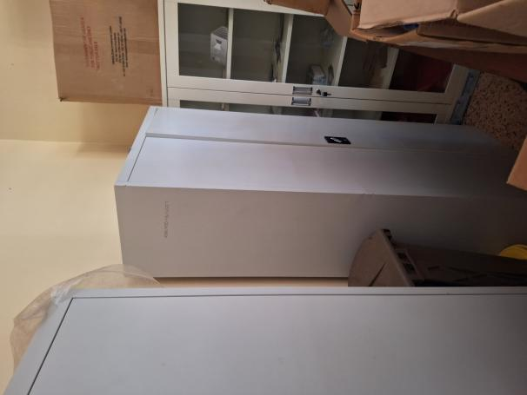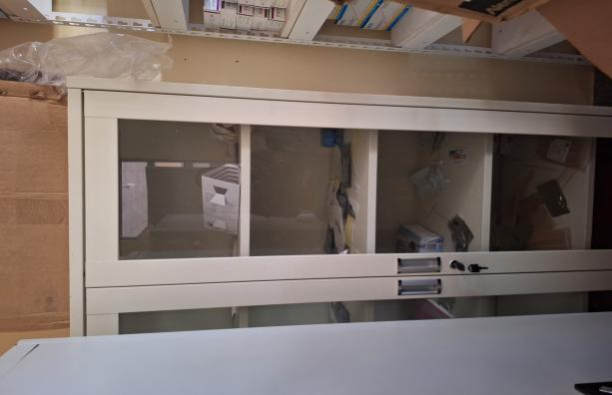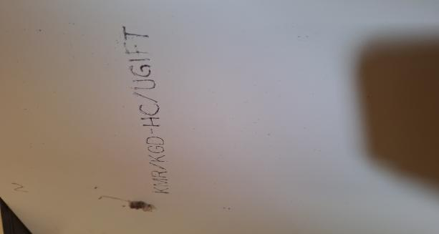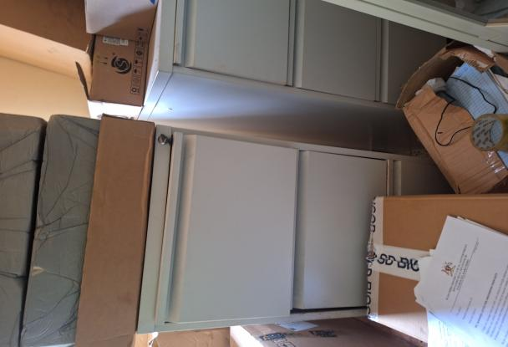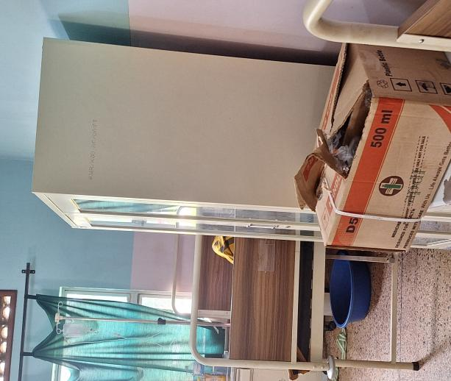
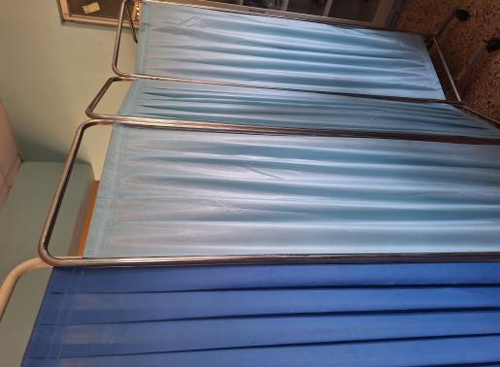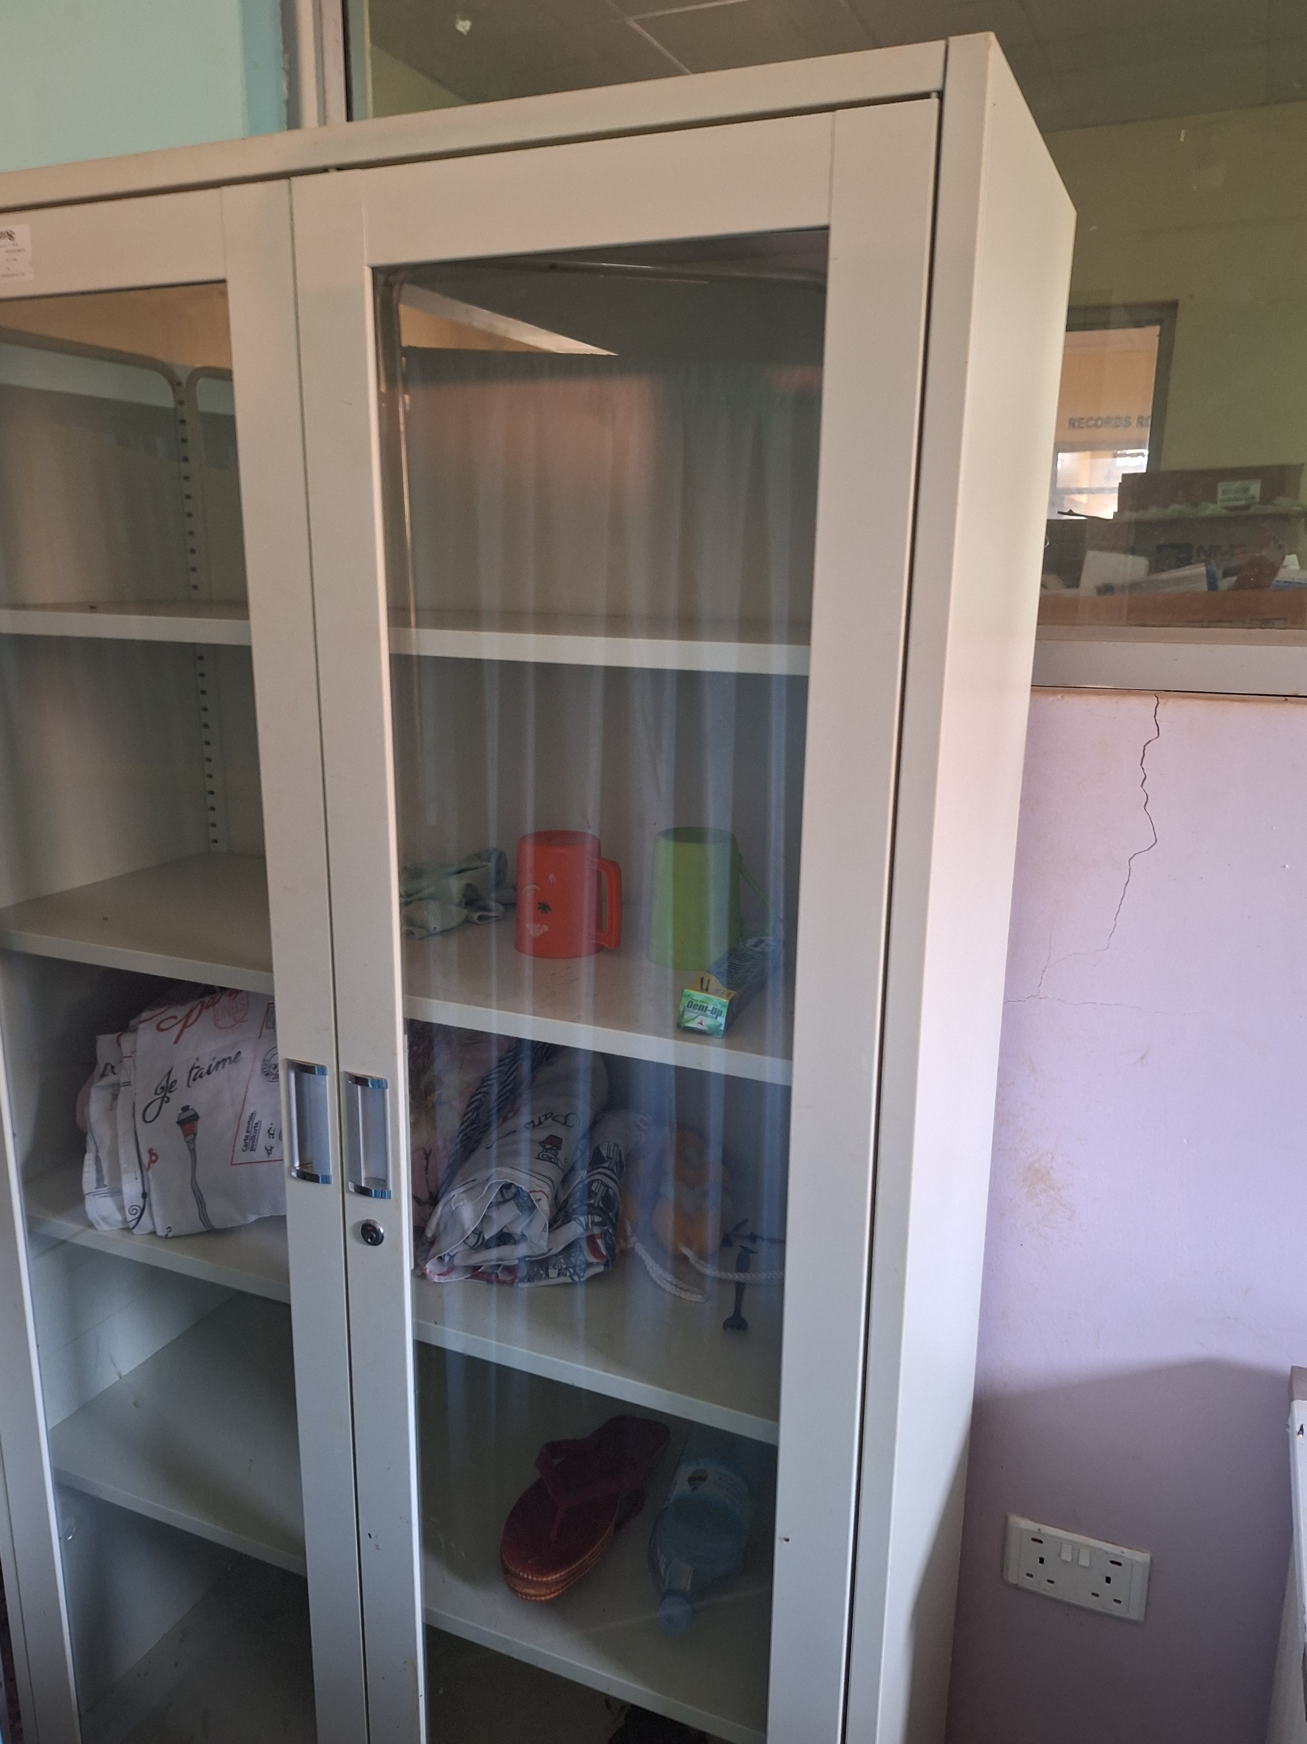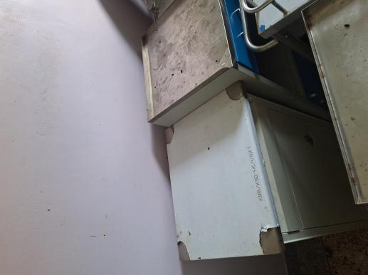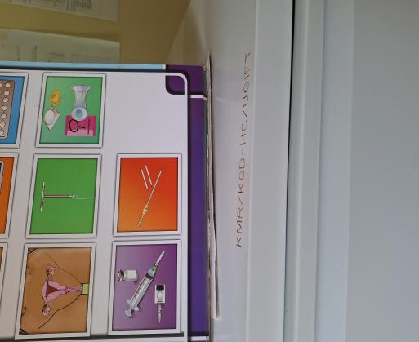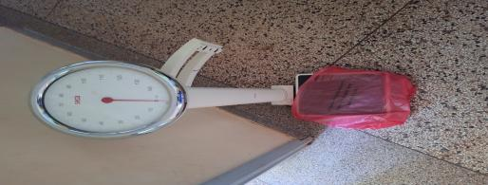

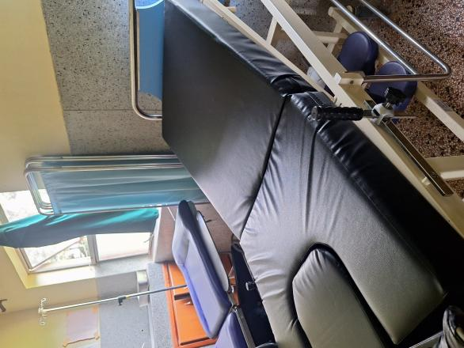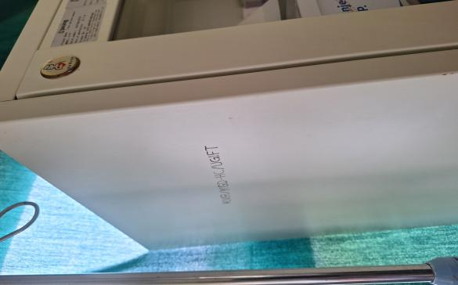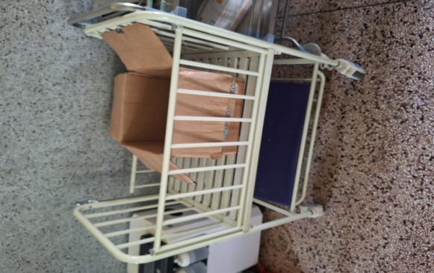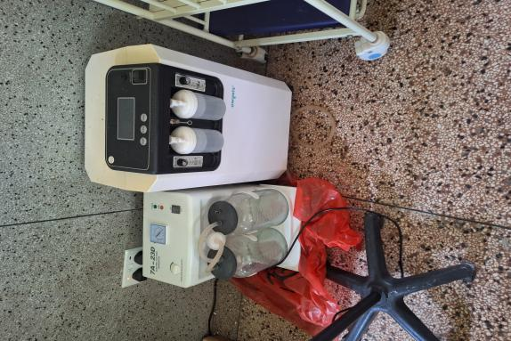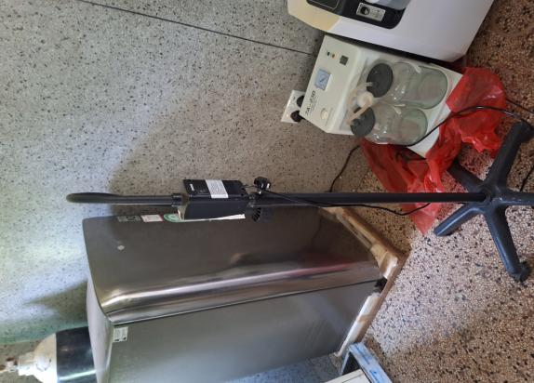
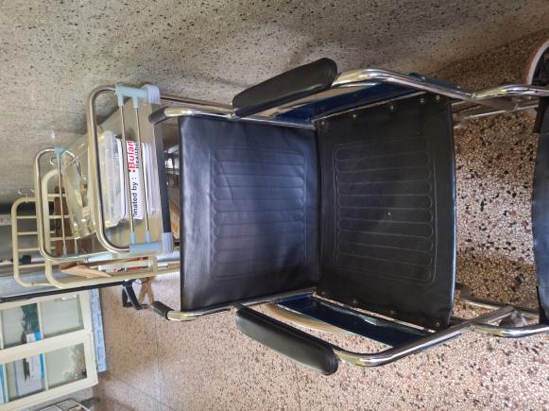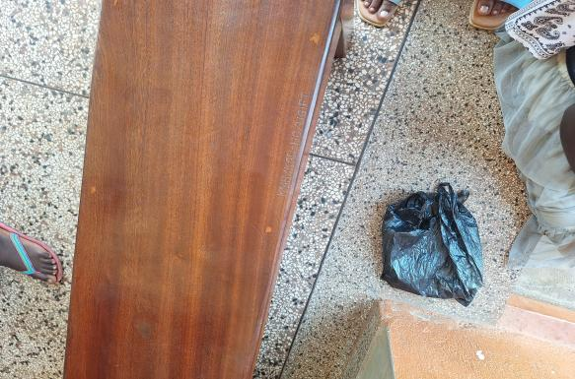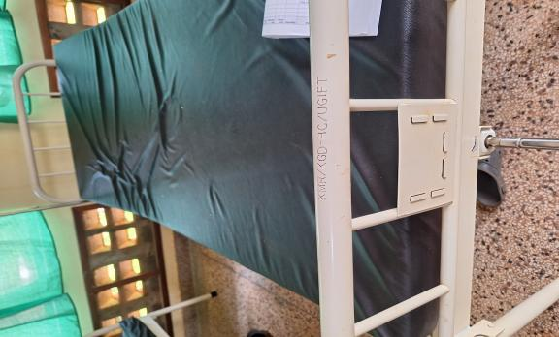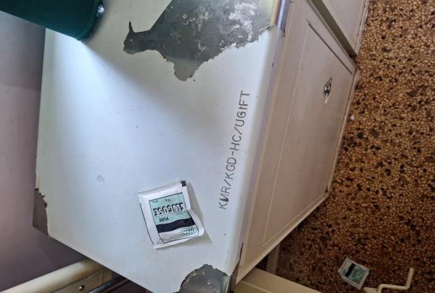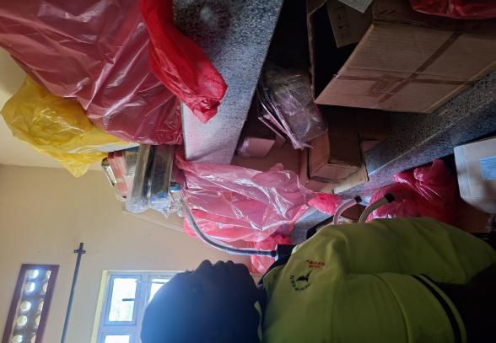

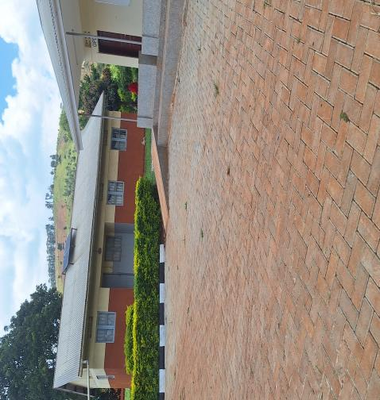
SCHOOL VERIFICATION CHECKLIST

SCHOOL INTERVIEW/DISCUSSION GUIDE

Name of school: ………………………………………………………………………………..

1a | Does the Facility have a record of all assets provided under UgIFT.  (Obtain a record and verify if it has the costs and numbers supplied
1b | If Not ask how many were supplied and when.

2 | How does this facility Maintain (repair/service/replace) the assets provided under Ugift

3 | Does the facility take regular record about functionality/ or breakdown of the assets provided?  Nonfunctional/ working, and reasons for non-functionality.

4 | How has the UgIFT support helped in service delivery in the area, any issues, challenges and any recommendations for better program implementation.

PROCEED TO VERIFICATION AFTER THIS DISCUSSION

SCHOOL FURNITURE
(School Desks, Office chairs, Laboratory stools, Book shelves)

Name of LG………………………………………………………………… Name of SCHOOL………………………………………………………………………………

Equipment/ Item | Department | Asset Number | Item  Description | Life in Months | Tag Number ( engrave no.) | Date Of Pur | Date Placed In Service | Recoverable cost | Cost | Acc Dep Cost | Net Book Value | Ytd Deprn | Equipment status | Remarks

ICT ITEMS TO VERIFY
(Desktop Computer, Server Processor, Network Switch 24 Port, Multipurpose Printer, UPS, Projector, Air Conditioners, Server, CCTV Camera)

Name of LG…………………………………………………………………………… Name of SCHOOL………………………….………………………………………

Equipment/ Item | Department | Asset Number | Item  Description | Life in Months | Tag Number ( engrave no.) | Date Of Pur | Date Placed In Service | Recoverable cost | Cost | Acc Dep Cost | Net Book Value | Ytd Deprn | Equipment status | Remarks

BUILDINGS TO VERIFY
(Non- Residential and Residential, Kitchen, Toilets/Pit latrine Water tanks, Fences etc.)

Name of LG…………………………………………………………………………… Name of SCHOOL………………………….………………………………………

Equipment/ Item | Department | Asset Number | Item  Description | Life in Months | Tag Number ( engrave no.) | Date Of Pur | Date Placed In Service | Recoverable cost | Cost | Acc Dep Cost | Net Book Value | Ytd Deprn | Equipment status | Remarks

